**MINI PROJECT**

**Controller Area Network Transmission Module Using Verilog HDL**

**Abstract:**

Controller Area Network or CAN protocol is a method of communication between various electronic devices. It defines a standard for efficient and reliable communication between sensor, actuator, controller, and other nodes in real-time applications. This provides a mechanism which is incorporated in the hardware and the software by which different electronic modules can communicate with each other using a common cable. CAN protocol is a message-based protocol, not an address-based protocol. All nodes in the system receive every message transmitted on the bus (and will acknowledge if the message was properly received). It is up to each node in the system to decide whether the message received should be immediately discarded or kept to be processed.

**Outcomes:**

The main aim is to design, development, and implementation of a CAN module using Verilog HDL is that to show that the designed CAN module can replace a standalone CAN controller which occupies extra space in the system. It has significant use in the industry of automobiles. Also implementing the CAN with the help of custom RAM is aimed at removing the need for FPGA specific RAM. The proposed design of CAN module is an integration of lower-level modules. The desired Verilog implementation of CAN module can help in simulating different systems at the design level instead of using physical ICs. The design includes a simple scheme that aims in reduction of circuit complexity and chances of hardware failure without requiring any extra logic circuitry.

// Code your design here

module can_tx(

output reg tx,

output reg can_bitstuff,

output reg txing,

input rx,

input[10:0] address,

input clk,

input baud_clk,

input rst,

input [7:0] data,

input send_data,

input bitstuffed_output,

input clear_to_tx

);

assign rx_buf = rx;

parameter all_ones = 15'b111111111111111;

parameter idle = 8'h0, start_of_frame = 8'h1, addressing =8'h2 ,rtr = 8'h3 ,ide = 8'h4, reserve_bit = 8'h5, num_of_bytes = 8'h6,

data_out = 8'h7, crc_out = 8'h8, crc_delimiter = 8'h9 , ack = 8'hA, ack_delimiter = 8'hB, end_of_frame = 8'hC, waiting = 8'hD;

parameter bytes = 5'd8;

reg[10:0] address_count = 0, crc_count = 0, eof_count = 0 , data_bit_count = 0, data_byte_count = 0;

reg[7:0] c_state=0, n_state=0;

initial txing = 0;

reg[14:0] crc_output, crc_holder;

wire one_shotted_send;

wire[14:0] crc_buff;

CRC cyclic_red_check(data, one_shotted_send, crc_buff,rst,clk);//caliing crc module

OneShot os(send_data, clk, rst, one_shotted_send);//calling one shot pulse module

always @(crc_buff or crc_holder) begin

if(crc_buff != all_ones)

crc_output <= crc_buff;

else

crc_output <= crc_holder;

end

always @ (posedge clk or posedge rst) begin

if(rst == 1) begin

crc_holder <= 15'd0;

end

else begin

crc_holder <= crc_output;

end

end

//Update Logic

always @ (posedge baud_clk or posedge rst) begin

if(rst == 1) begin

c_state <= 32'd0;

end

else begin

c_state <= n_state;

end

end

//Counting Logic

always @ (posedge baud_clk) begin

case(c_state)

idle: begin

address_count <= 11'd0;

data_bit_count<= 11'd0;

data_byte_count<= 11'd0;

crc_count <= 11'd0;

eof_count <= 11'd0;

end

waiting: begin

address_count <= 11'd0;

data_bit_count<= 11'd0;

data_byte_count<= 11'd0;

crc_count <= 11'd0;

eof_count <= 11'd0;

end

start_of_frame:begin

address_count <= 11'd0;

data_bit_count<= 11'd0;

data_byte_count<= 11'd0;

crc_count <= 11'd0;

eof_count <= 11'd0;

end

addressing: begin

address_count <= address_count + 1'b1;

data_bit_count<= 11'd0;

data_byte_count<= 11'd0;

crc_count <= 11'd0;

eof_count <= 11'd0;

end

rtr: begin

address_count <= 11'd0;

data_bit_count<= 11'd0;

data_byte_count<= 11'd0;

crc_count <= 11'd0;

eof_count <= 11'd0;

end

ide: begin

address_count <= 11'd0;

data_bit_count<= 11'd0;

data_byte_count<= 11'd0;

crc_count <= 11'd0;

eof_count <= 11'd0;

end

reserve_bit: begin

address_count <= 11'd0;

data_bit_count<= 11'd0;

data_byte_count<= 11'd0;

crc_count <= 11'd0;

eof_count <= 11'd0;

end

num_of_bytes: begin

address_count <= 11'd0;

data_bit_count<= 11'd0;

data_byte_count<= data_byte_count +1'b1;

crc_count <= 11'd0;

eof_count <= 11'd0;

end

data_out: begin

address_count <= 11'd0;

data_bit_count<= data_bit_count +1'b1;

data_byte_count<= 11'd0;

crc_count <= 11'd0;

eof_count <= 11'd0;

end

crc_out: begin

address_count <= 11'd0;

data_bit_count<= 11'd0;

data_byte_count<= 11'd0;

crc_count <= crc_count + 1'b1;

eof_count <= 11'd0;

end

crc_delimiter: begin

address_count <= 11'd0;

data_bit_count<= 11'd0;

data_byte_count<= 11'd0;

crc_count <= 11'd0;

eof_count <= 11'd0;

end

ack: begin

address_count <= 11'd0;

data_bit_count<= 11'd0;

data_byte_count<= 11'd0;

crc_count <= 11'd0;

eof_count <= 11'd0;

end

ack_delimiter:begin

address_count <= 11'd0;

data_bit_count<= 11'd0;

data_byte_count<= 11'd0;

crc_count <= 11'd0;

eof_count <= 11'd0;

end

end_of_frame: begin

address_count <= 11'd0;

data_bit_count<= 11'd0;

data_byte_count<= 11'd0;

crc_count <= 11'd0;

eof_count <= eof_count +1'b1;

end

default: begin

address_count <= 11'd0;

data_bit_count<= 11'd0;

data_byte_count<= 11'd0;

crc_count <= 11'd0;

eof_count <= 11'd0;

end

endcase

end

//Next State Logic

always @ (c_state or rx_buf or data or send_data or address_count or bitstuffed_output or data_byte_count

or data_bit_count or crc_count or eof_count or clear_to_tx or crc_output) begin

case(c_state)

idle: begin

if(send_data && clear_to_tx) begin

n_state <= start_of_frame;

end

else begin

n_state <= idle;

end

end

start_of_frame: begin

if(!rx_buf) begin

n_state <= addressing;

end

else begin

n_state <= waiting;

end

end

waiting: begin

if(send_data && clear_to_tx) begin

n_state <= start_of_frame;

end

else begin

n_state <= waiting;

end

end

addressing: begin

if(rx_buf != bitstuffed_output) begin

n_state <= waiting; //Lost Arbitration

end

else if(address_count == 11'd10) begin

n_state <= rtr;

end

else begin

n_state <= addressing;

end

end

rtr: begin

n_state <= ide;

end

ide: begin

n_state <= reserve_bit;

end

reserve_bit: begin

n_state <= num_of_bytes;

end

num_of_bytes: begin

if(data_byte_count == 11'd3) begin

n_state <= data_out;

end

else begin

n_state <= num_of_bytes;

end

end

data_out: begin

if(data_bit_count == 11'd63) begin

n_state <= crc_out;

end

else begin

n_state <= data_out;

end

end

crc_out: begin

if(crc_count == 11'd14) begin

n_state <= crc_delimiter;

end

else begin

n_state <= crc_out;

end

end

crc_delimiter: begin

n_state <= ack;

end

ack: begin

n_state <= ack_delimiter;

end

ack_delimiter: begin

n_state <= end_of_frame;

end

end_of_frame: begin

if(eof_count == 11'd6) begin

n_state <= idle;

end

else begin

n_state <= end_of_frame;

end

end

default:

begin

n_state <= idle;

end

endcase

end

//Output Logic

always @(c_state or address or data or crc_output or crc_count or data_byte_count or data_bit_count or address_count) begin

case(c_state)

idle: begin

tx <= 1;

can_bitstuff <= 0;

txing <= 1'b0;

end

addressing: begin

tx <= address[11'd10-address_count];

can_bitstuff <= 1;

txing <= 1'b1;

end

start_of_frame: begin

tx<= 0;

can_bitstuff <= 1'b0;

txing <= 1'b1;

end

rtr: begin

tx <= 0;

can_bitstuff <= 1;

txing <= 1'b1;

end

ide: begin

tx <= 0;

can_bitstuff <= 1;

txing <= 1'b1;

end

reserve_bit: begin

tx <= 0;

can_bitstuff <= 1;

txing <= 1'b1;

end

num_of_bytes: begin

tx <= bytes[11'd3-data_byte_count];

can_bitstuff <= 1;

txing <= 1'b1;

end

data_out: begin

tx <= data[11'd63-data_bit_count];

can_bitstuff <= 1;

txing <= 1'b1;

end

crc_out: begin

tx <= crc_output[11'd14-crc_count];

can_bitstuff <= 1;

txing <= 1'b1;

end

crc_delimiter: begin

tx <= 1;

can_bitstuff <= 0;

txing <= 1'b1;

end

ack: begin

tx <= 1;

can_bitstuff <= 0;

txing <= 1'b1;

end

ack_delimiter:begin

tx <= 1;

can_bitstuff <= 0;

txing <= 1'b1;

end

end_of_frame: begin

tx <= 1;

can_bitstuff <= 0;

txing <= 1'b1;

end

waiting: begin

tx <= 1;

can_bitstuff <= 0;

txing <= 1'b0;

end

default: begin

tx <= 1;

can_bitstuff <= 0;

txing <= 1'b1;

end

endcase

end

endmodule

module CRC (

input [7:0] data_in,

input crc_en,

output reg [4:0] crc_out,

input clk,

input reset

);

reg [4:0] lfsr_q, lfsr_c;

always @* begin

lfsr_c[0] = data_in[7] ^ data_in[5] ^ data_in[4] ^ data_in[3] ^ data_in[0] ^ lfsr_q[4] ^ lfsr_q[3] ^ lfsr_q[2] ^ lfsr_q[0];

lfsr_c[1] = data_in[7] ^ data_in[6] ^ data_in[5] ^ data_in[2] ^ data_in[0] ^ lfsr_q[4] ^ lfsr_q[3] ^ lfsr_q[1];

lfsr_c[2] = data_in[6] ^ data_in[5] ^ data_in[4] ^ data_in[1] ^ data_in[0] ^ lfsr_q[4] ^ lfsr_q[2];

lfsr_c[3] = data_in[7] ^ data_in[5] ^ data_in[4] ^ data_in[3] ^ data_in[1] ^ lfsr_q[3] ^ lfsr_q[1] ^ lfsr_q[0];

lfsr_c[4] = data_in[6] ^ data_in[5] ^ data_in[2] ^ data_in[1] ^ lfsr_q[4] ^ lfsr_q[2] ^ lfsr_q[1] ^ lfsr_q[0];

end

always @(posedge clk, posedge reset) begin

if (reset)

lfsr_q <= 0;

else

lfsr_q <= lfsr_c;

end

always @(posedge clk) begin

crc_out <= lfsr_q;

end

endmodule

module OneShot(

input pulse,

input clk,

input rst,

output reg out

);

initial out = 0;

parameter waiting_l = 2'b00, on = 2'b01, waiting_h = 2'b10;

reg[1:0] next_state, current_state;

always @ (posedge clk or posedge rst) begin

if(rst) begin

current_state <= waiting_l;

end

else begin

current_state <= next_state;

end

end

always @ (current_state or pulse) begin

if(current_state == on) begin

next_state <= waiting_h;

end

else if(current_state == waiting_h) begin

if(pulse) begin

next_state <= waiting_h;

end

else begin

next_state <= waiting_l;

end

end

else if(pulse) begin

next_state<= on;

end

else begin

next_state<= waiting_l;

end

end

always @(current_state or rst) begin

if(rst)

out <= 1'b0;

else if(current_state == on)

out <= 1'b1;

else

out <= 1'b0;

end

endmodule

**TESTBENCH CODE:**

module can_tx_tb;

parameter CLK_PERIOD = 10;

parameter SIM_TIME = 500;

// Signals

reg clk = 0;

reg baud_clk = 0;

reg rst = 1;

reg send_data = 0;

reg bitstuffed_output = 0;

reg clear_to_tx = 1;

reg rx = 0;

reg [10:0] address = 11'd0;

reg [7:0] data = 8'd0;

reg pulse;

wire tx;

wire can_bitstuff;

wire txing;

wire out;

// Instantiate the modules

can_tx dut (

.tx(tx),

.can_bitstuff(can_bitstuff),

.txing(txing),

.rx(rx),

.address(address),

.clk(clk),

.baud_clk(baud_clk),

.rst(rst),

.data(data),

.send_data(send_data),

.bitstuffed_output(bitstuffed_output),

.clear_to_tx(clear_to_tx)

);

OneShot os (

.pulse(pulse),

.clk(clk),

.rst(rst),

.out(out)

);

// Clock generation

always #((CLK_PERIOD/2)) clk = ~clk;

always #5 baud_clk = ~baud_clk;

initial begin

rst = 1;

#20 rst = 0;

#50 send_data = 1;

#10 send_data = 0;

#100 rx = 1;

#10 rx = 0;

#50 address = 11'd123;

#70 data = 8'd255;

#150 pulse = 1;

#10 pulse = 0;

#200 $finish;

end

// Display output

always @(posedge clk) begin

$display("Time = %0t: tx = %b, can_bitstuff = %b, txing = %b, out = %b", $time, tx, can_bitstuff, txing, out);

end

initial begin

$dumpfile("dump.vcd");

$dumpvars(0);

end

endmodule

**OUTPUT:**

**Can_tx_tb**

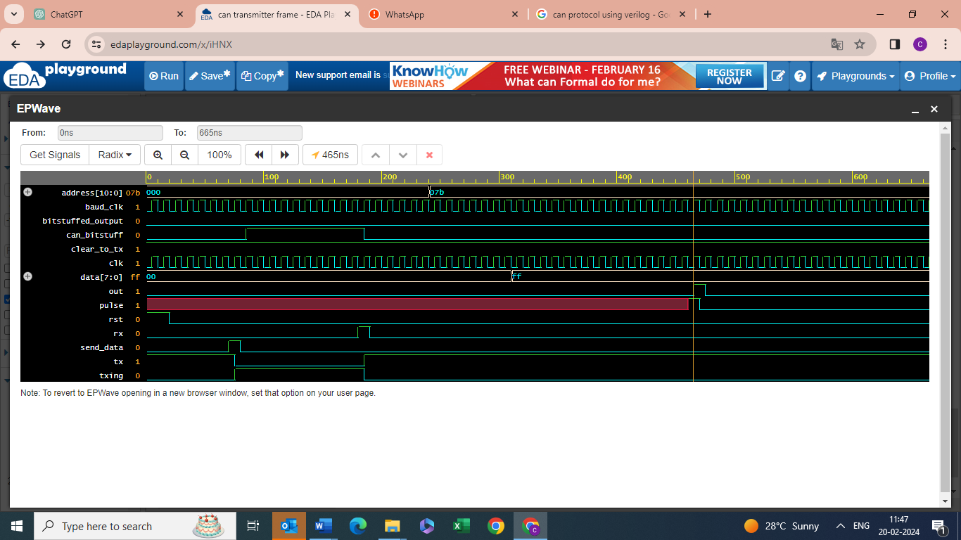

**Dut_tb:**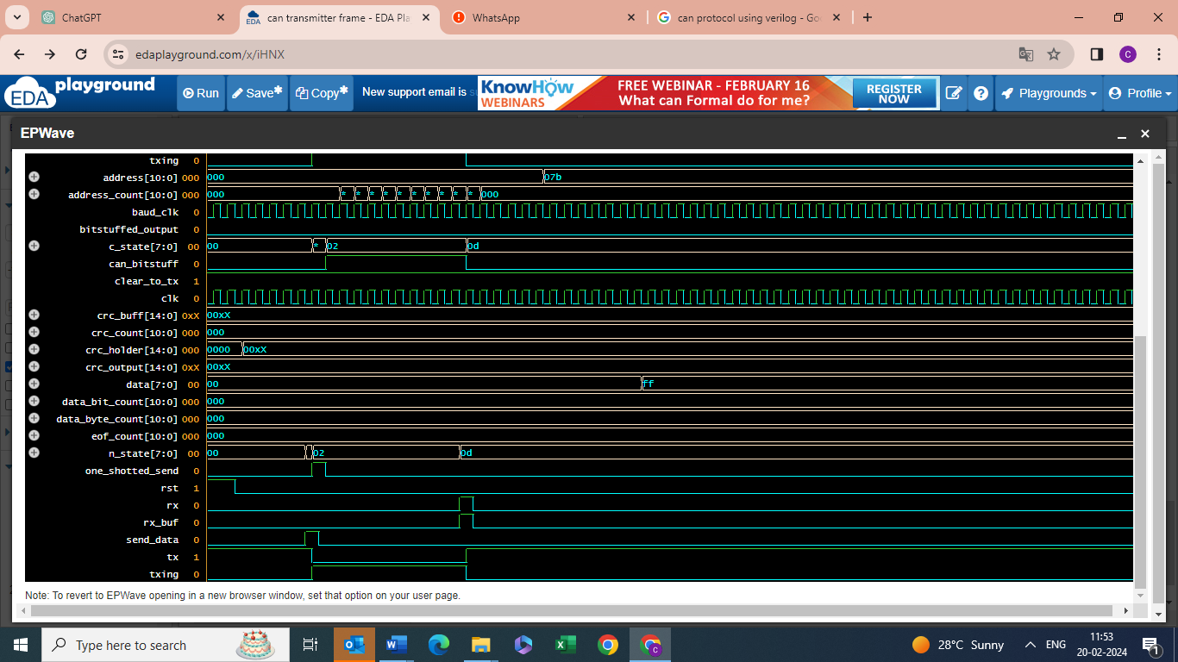

**os_tb:**

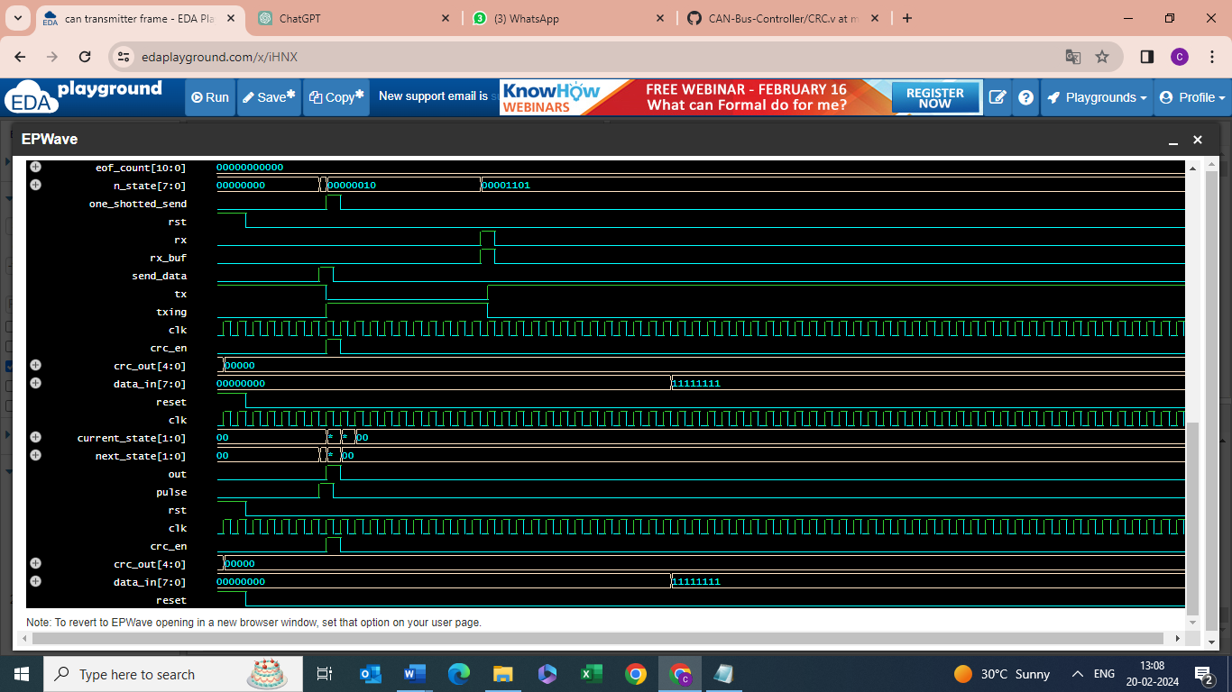

**crc_tb:**



Time = 5: tx = 1, can_bitstuff = 0, txing = 0, out = 0

Time = 15: tx = 1, can_bitstuff = 0, txing = 0, out = 0

Time = 25: tx = 1, can_bitstuff = 0, txing = 0, out = 0

Time = 35: tx = 1, can_bitstuff = 0, txing = 0, out = 0

Time = 45: tx = 1, can_bitstuff = 0, txing = 0, out = 0

Time = 55: tx = 1, can_bitstuff = 0, txing = 0, out = 0

Time = 65: tx = 1, can_bitstuff = 0, txing = 0, out = 0

Time = 75: tx = 1, can_bitstuff = 0, txing = 0, out = 0

Time = 85: tx = 0, can_bitstuff = 0, txing = 1, out = 0

Time = 95: tx = 0, can_bitstuff = 1, txing = 1, out = 0

Time = 105: tx = 0, can_bitstuff = 1, txing = 1, out = 0

Time = 115: tx = 0, can_bitstuff = 1, txing = 1, out = 0

Time = 125: tx = 0, can_bitstuff = 1, txing = 1, out = 0

Time = 135: tx = 0, can_bitstuff = 1, txing = 1, out = 0

Time = 145: tx = 0, can_bitstuff = 1, txing = 1, out = 0

Time = 155: tx = 0, can_bitstuff = 1, txing = 1, out = 0

Time = 165: tx = 0, can_bitstuff = 1, txing = 1, out = 0

Time = 175: tx = 0, can_bitstuff = 1, txing = 1, out = 0

Time = 185: tx = 0, can_bitstuff = 1, txing = 1, out = 0

Time = 195: tx = 1, can_bitstuff = 0, txing = 0, out = 0

Time = 205: tx = 1, can_bitstuff = 0, txing = 0, out = 0

Time = 215: tx = 1, can_bitstuff = 0, txing = 0, out = 0

Time = 225: tx = 1, can_bitstuff = 0, txing = 0, out = 0

Time = 235: tx = 1, can_bitstuff = 0, txing = 0, out = 0

Time = 245: tx = 1, can_bitstuff = 0, txing = 0, out = 0

Time = 255: tx = 1, can_bitstuff = 0, txing = 0, out = 0

Time = 265: tx = 1, can_bitstuff = 0, txing = 0, out = 0

Time = 275: tx = 1, can_bitstuff = 0, txing = 0, out = 0

Time = 285: tx = 1, can_bitstuff = 0, txing = 0, out = 0

Time = 295: tx = 1, can_bitstuff = 0, txing = 0, out = 0

Time = 305: tx = 1, can_bitstuff = 0, txing = 0, out = 0

Time = 315: tx = 1, can_bitstuff = 0, txing = 0, out = 0

Time = 325: tx = 1, can_bitstuff = 0, txing = 0, out = 0

Time = 335: tx = 1, can_bitstuff = 0, txing = 0, out = 0

Time = 345: tx = 1, can_bitstuff = 0, txing = 0, out = 0

Time = 355: tx = 1, can_bitstuff = 0, txing = 0, out = 0

Time = 365: tx = 1, can_bitstuff = 0, txing = 0, out = 0

Time = 375: tx = 1, can_bitstuff = 0, txing = 0, out = 0

Time = 385: tx = 1, can_bitstuff = 0, txing = 0, out = 0

Time = 395: tx = 1, can_bitstuff = 0, txing = 0, out = 0

Time = 405: tx = 1, can_bitstuff = 0, txing = 0, out = 0

Time = 415: tx = 1, can_bitstuff = 0, txing = 0, out = 0

Time = 425: tx = 1, can_bitstuff = 0, txing = 0, out = 0

Time = 435: tx = 1, can_bitstuff = 0, txing = 0, out = 0

Time = 445: tx = 1, can_bitstuff = 0, txing = 0, out = 0

Time = 455: tx = 1, can_bitstuff = 0, txing = 0, out = 0

Time = 465: tx = 1, can_bitstuff = 0, txing = 0, out = 0

Time = 475: tx = 1, can_bitstuff = 0, txing = 0, out = 1

Time = 485: tx = 1, can_bitstuff = 0, txing = 0, out = 0

Time = 495: tx = 1, can_bitstuff = 0, txing = 0, out = 0

Time = 505: tx = 1, can_bitstuff = 0, txing = 0, out = 0

Time = 515: tx = 1, can_bitstuff = 0, txing = 0, out = 0

Time = 525: tx = 1, can_bitstuff = 0, txing = 0, out = 0

Time = 535: tx = 1, can_bitstuff = 0, txing = 0, out = 0

Time = 545: tx = 1, can_bitstuff = 0, txing = 0, out = 0

Time = 555: tx = 1, can_bitstuff = 0, txing = 0, out = 0

Time = 565: tx = 1, can_bitstuff = 0, txing = 0, out = 0

Time = 575: tx = 1, can_bitstuff = 0, txing = 0, out = 0

Time = 585: tx = 1, can_bitstuff = 0, txing = 0, out = 0

Time = 595: tx = 1, can_bitstuff = 0, txing = 0, out = 0

Time = 605: tx = 1, can_bitstuff = 0, txing = 0, out = 0

Time = 615: tx = 1, can_bitstuff = 0, txing = 0, out = 0

Time = 625: tx = 1, can_bitstuff = 0, txing = 0, out = 0

Time = 635: tx = 1, can_bitstuff = 0, txing = 0, out = 0

Time = 645: tx = 1, can_bitstuff = 0, txing = 0, out = 0

Time = 655: tx = 1, can_bitstuff = 0, txing = 0, out = 0

Time = 665: tx = 1, can_bitstuff = 0, txing = 0, out = 0

$finish called from file "testbench.sv", line 68.